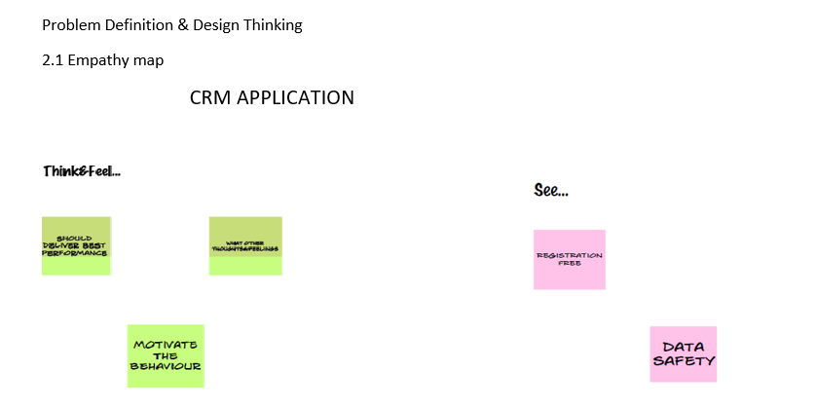

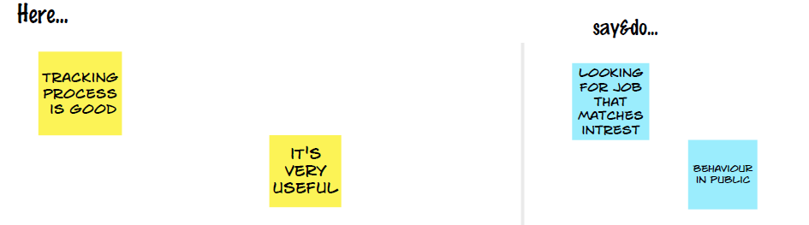

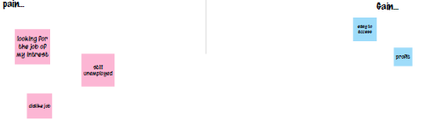

2.2 Ideation & Brainstorming Map

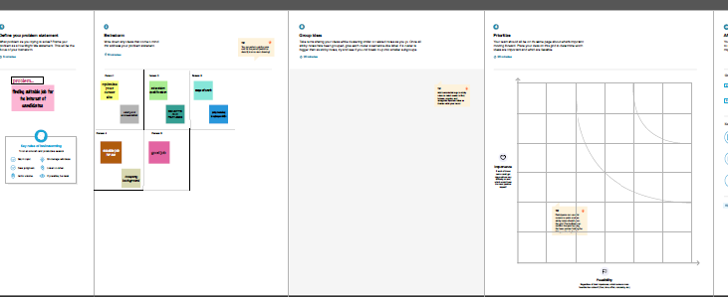

3 RESULT

3.1 Data Model:

|  |  |
| --- | --- |
| Object name | Field in the object |
| Obj 1 | Field lable data type  Candidate Custom Object |
| Obj 2 | Field lable data type  Custom1 Custom Object |
| Obj 3 | Field lable data type  Job Text |
| Obj 4 | Field lable data type  Job application Text |
| Obj 5 | Field lable data type  Recruiter Auto Number |
| Obj 6 | Field lable data type  location Text area |
|  |  |

3.2 Activity & Screenshot

The setup page will appear as below

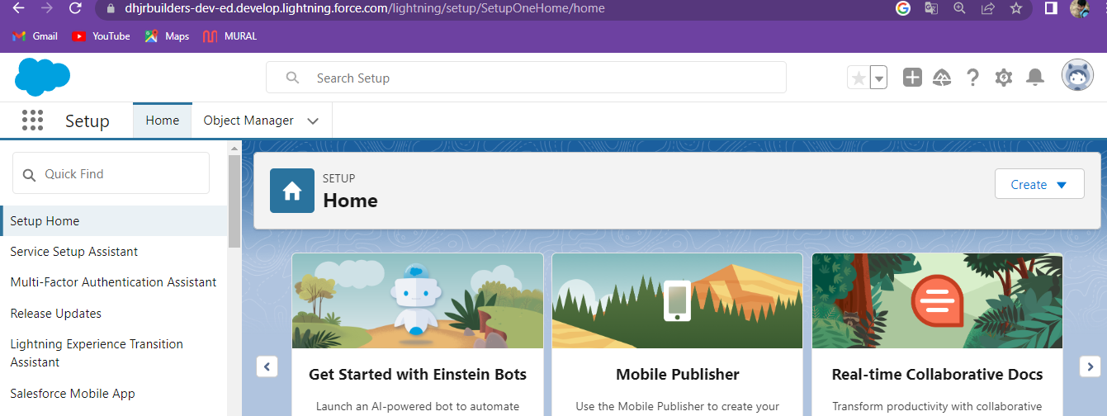

Create a custom object for Recruiter:

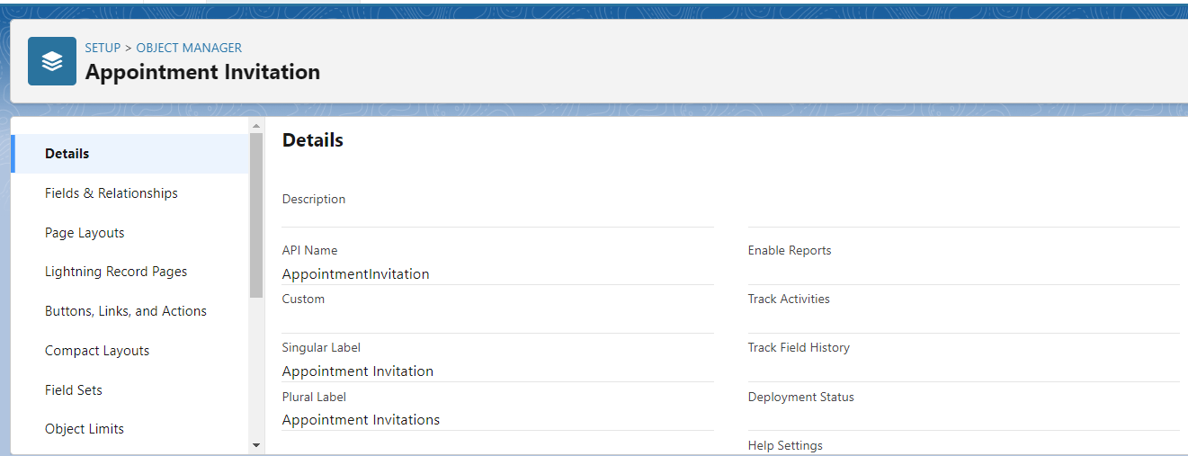

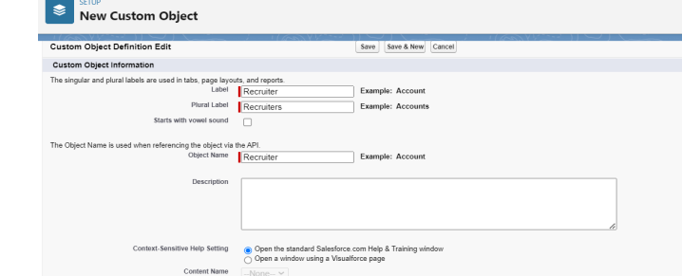

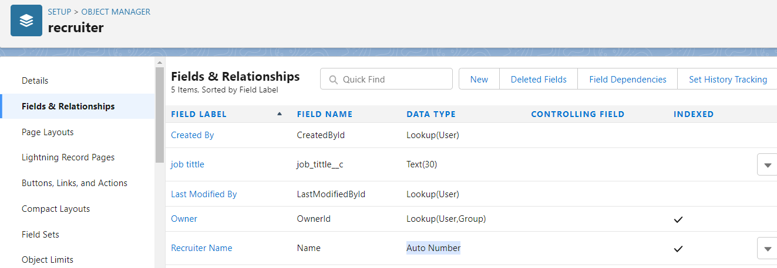

Activity 2:

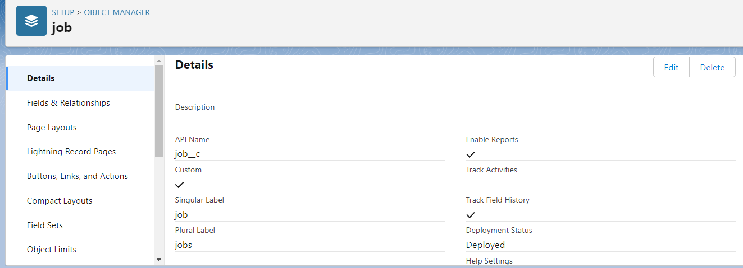

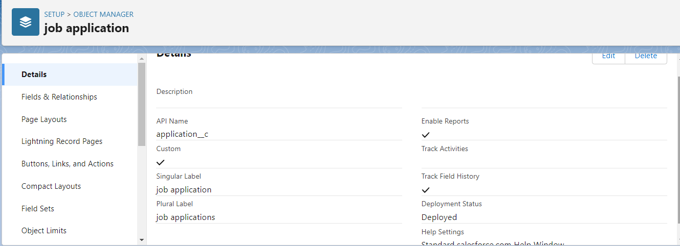

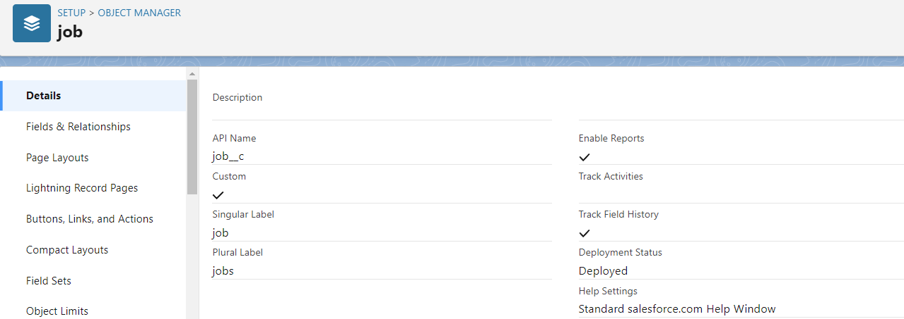

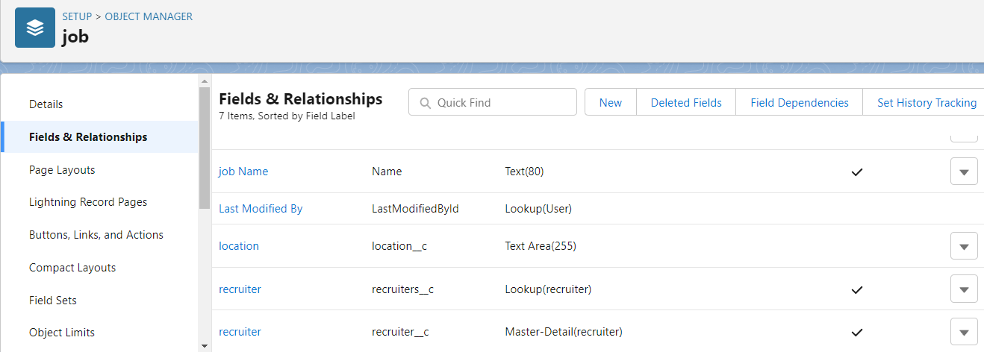

Create a tab

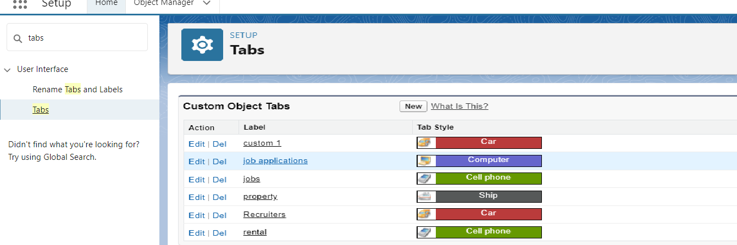

Create a custom profile

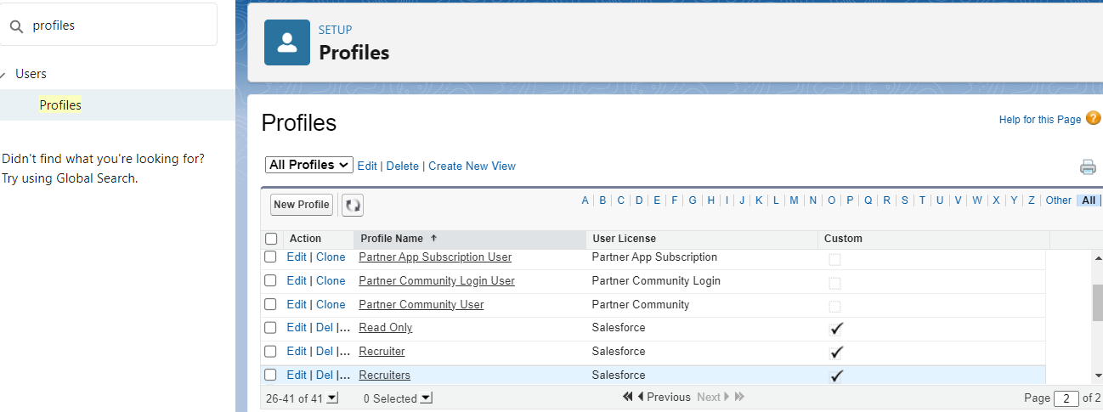

Create sales manager

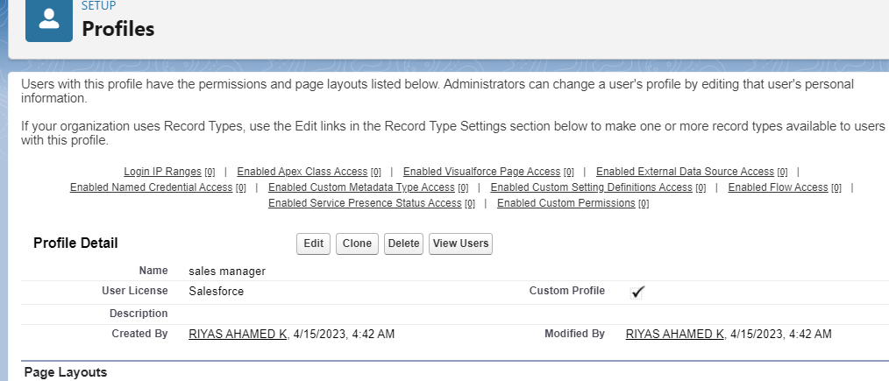

To Create a user:

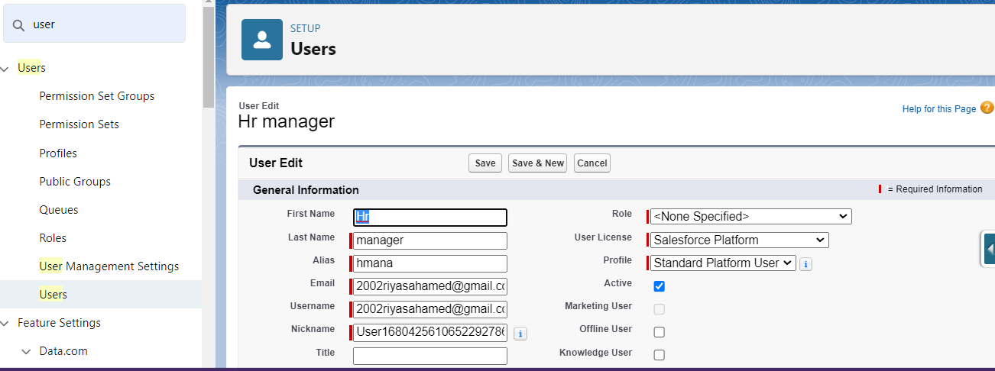

Activity 2:

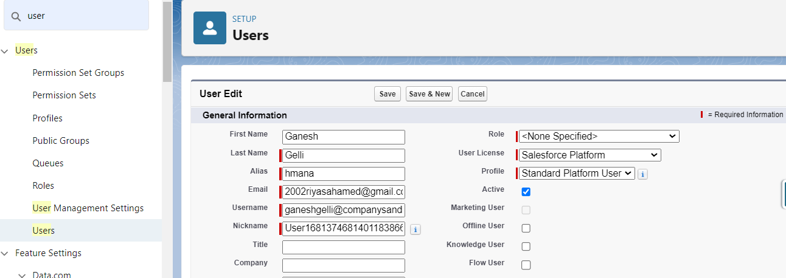

Create a sharing rule

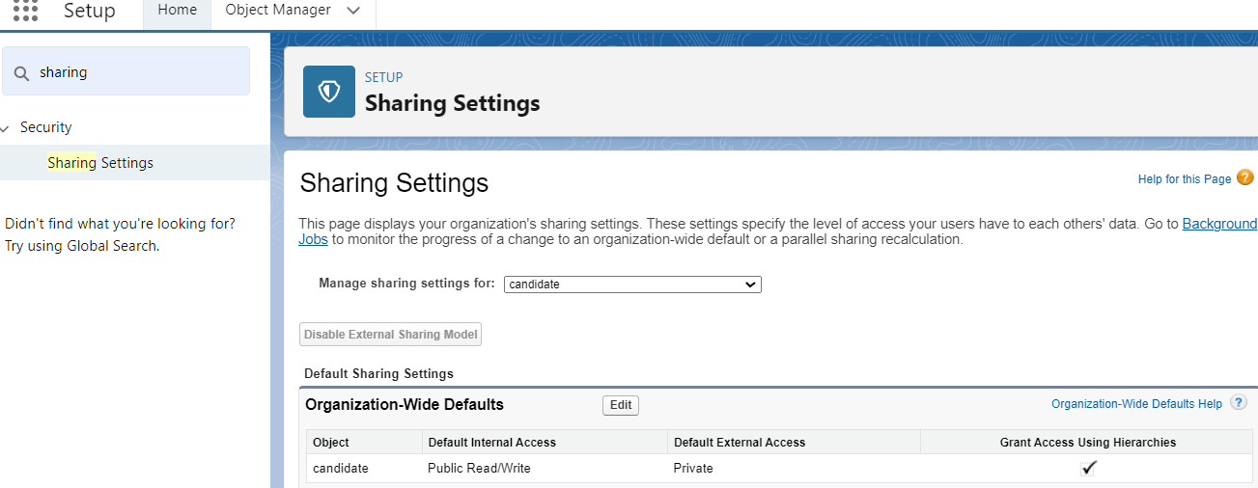

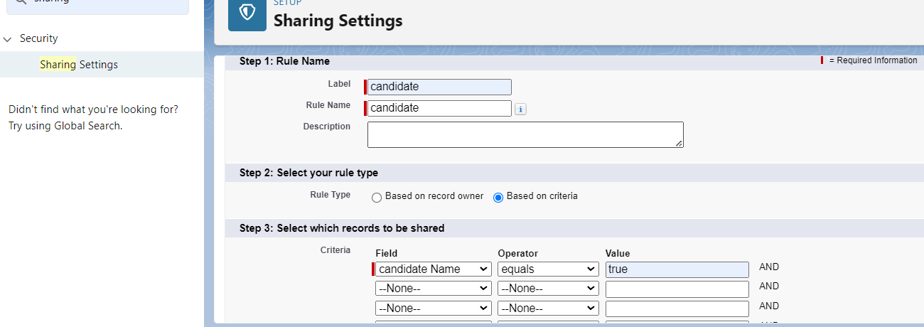

Create a report:

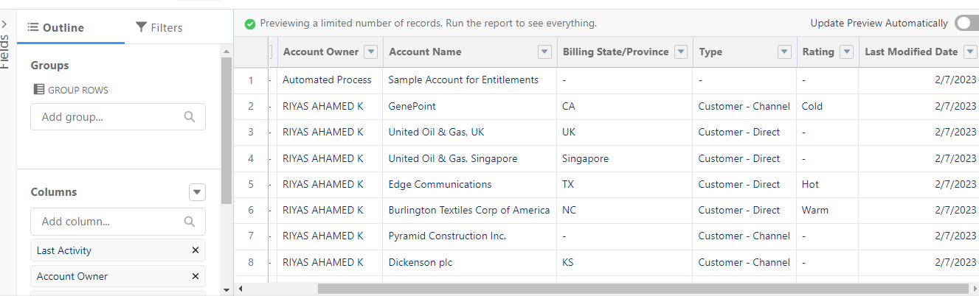

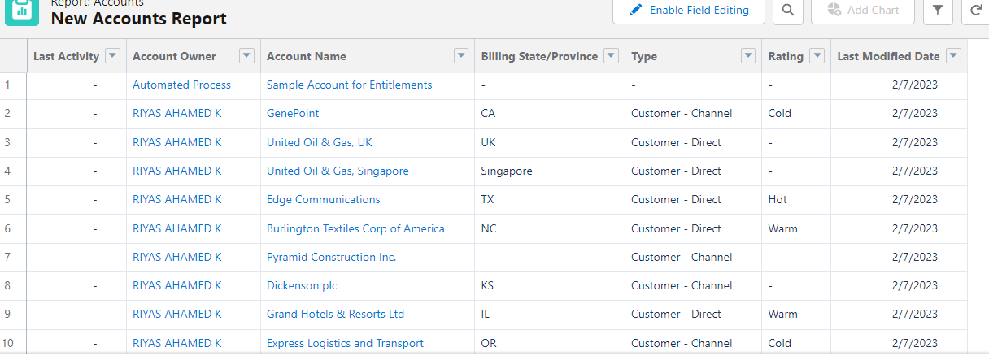

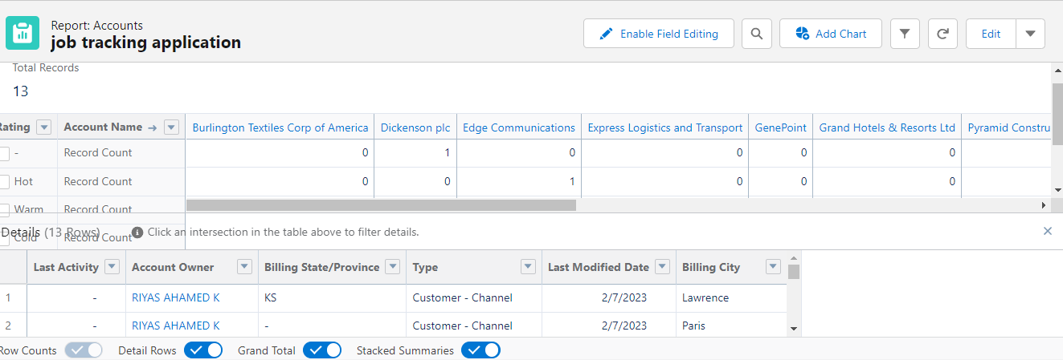

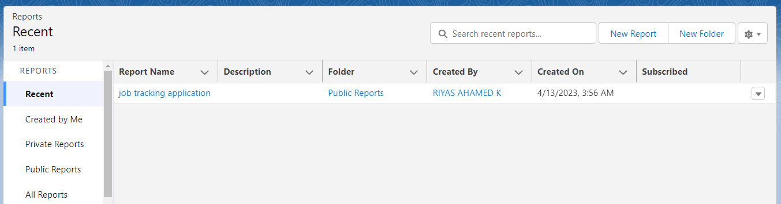

4 Trailhead Profile Public URL

Team Lead - https://trailblazer.me/id/raook

Team Member 1 –

Team Member 2 –

Team Member 3